How to set local Maven repo :

Create the maven setting.xml(rename to stack.xml) file.

Inside this xml file add below tag.

<localRepository>C:\Users\nishchay\m2_20.12</localRepository>

How to change maven installation to local environment maven.

Under window->preferences->maven->installations.

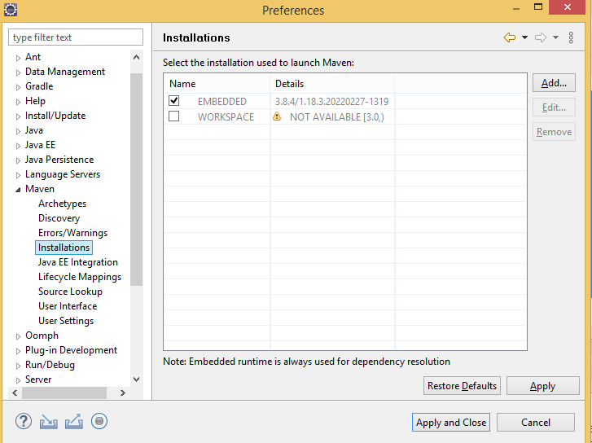

In Eclipse how to provided this xml file to maven.

Under window->preferences->maven->usersetttings

